EXPERIMENT 2
Designing and Implementing ETL Processes using Microsoft Power BI

Aim:
To design and implement an end-to-end ETL (Extract, Transform, Load) pipeline using Microsoft Power BI's Power Query Editor, enabling the extraction of data from a real-world business dataset, application of transformation logic, and loading of cleansed data into a unified analytical model for reporting and decision-making.

Steps to Perform the Experiment:
Step 1: Download the Global Superstore Dataset from Kaggle and launch Microsoft Power BI Desktop on your workstation.
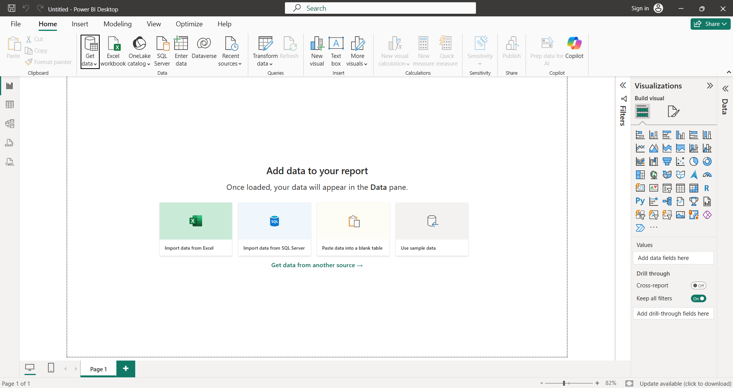

Step 2: Go to Home > Get Data > Excel Workbook, select the Global Superstore file, and then click on 'Transform Data'.
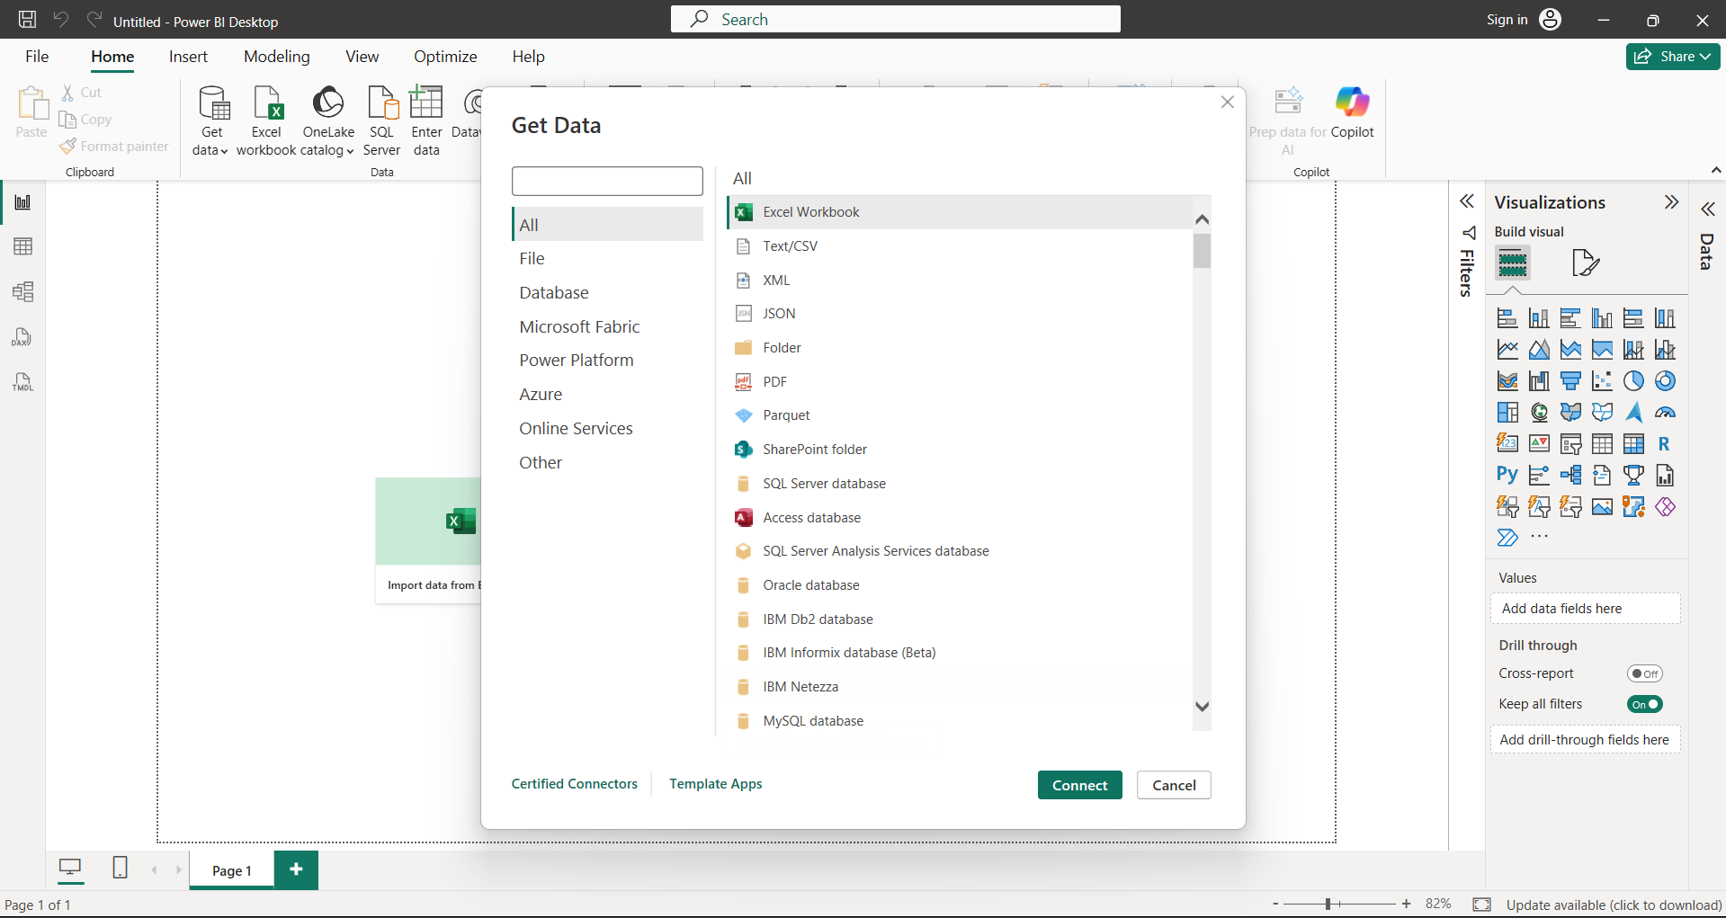

Step 3: In the Navigator box, select the 'Orders', 'Returns', and 'People' worksheets to extract them into the Queries pane.
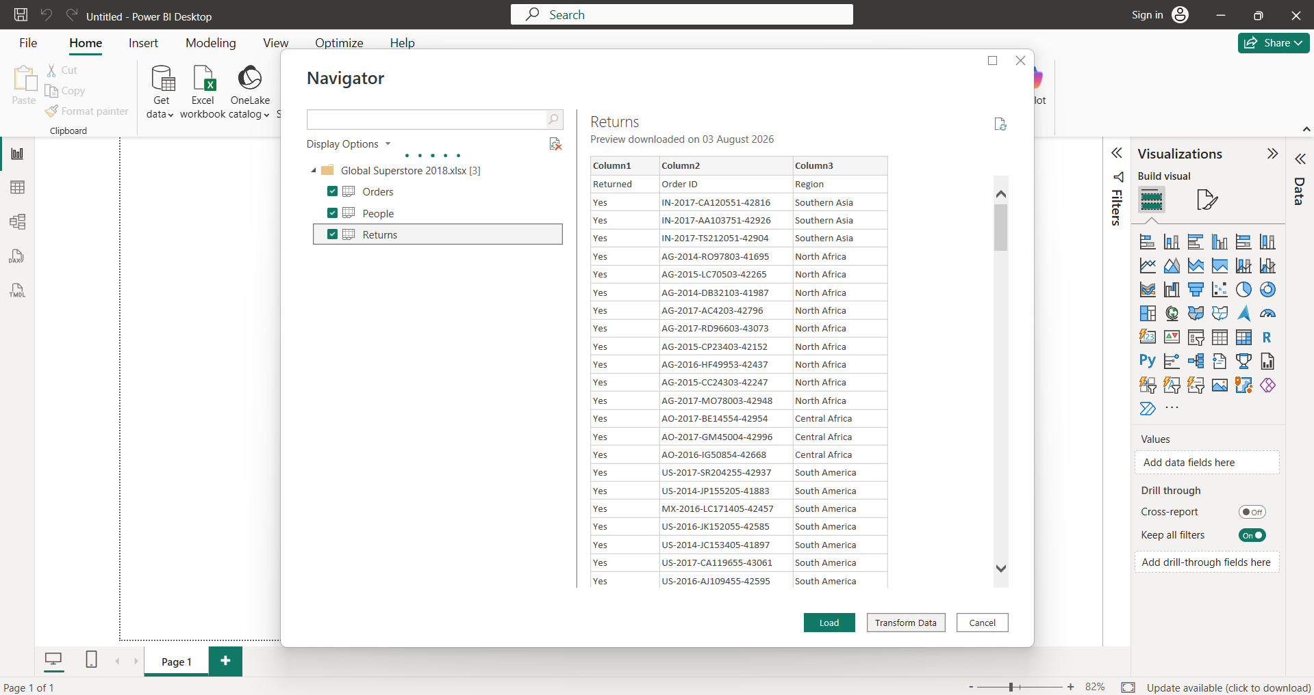

Step 4: Launch the Power Query Editor environment to begin applying data cleaning routines to your extracted tables.
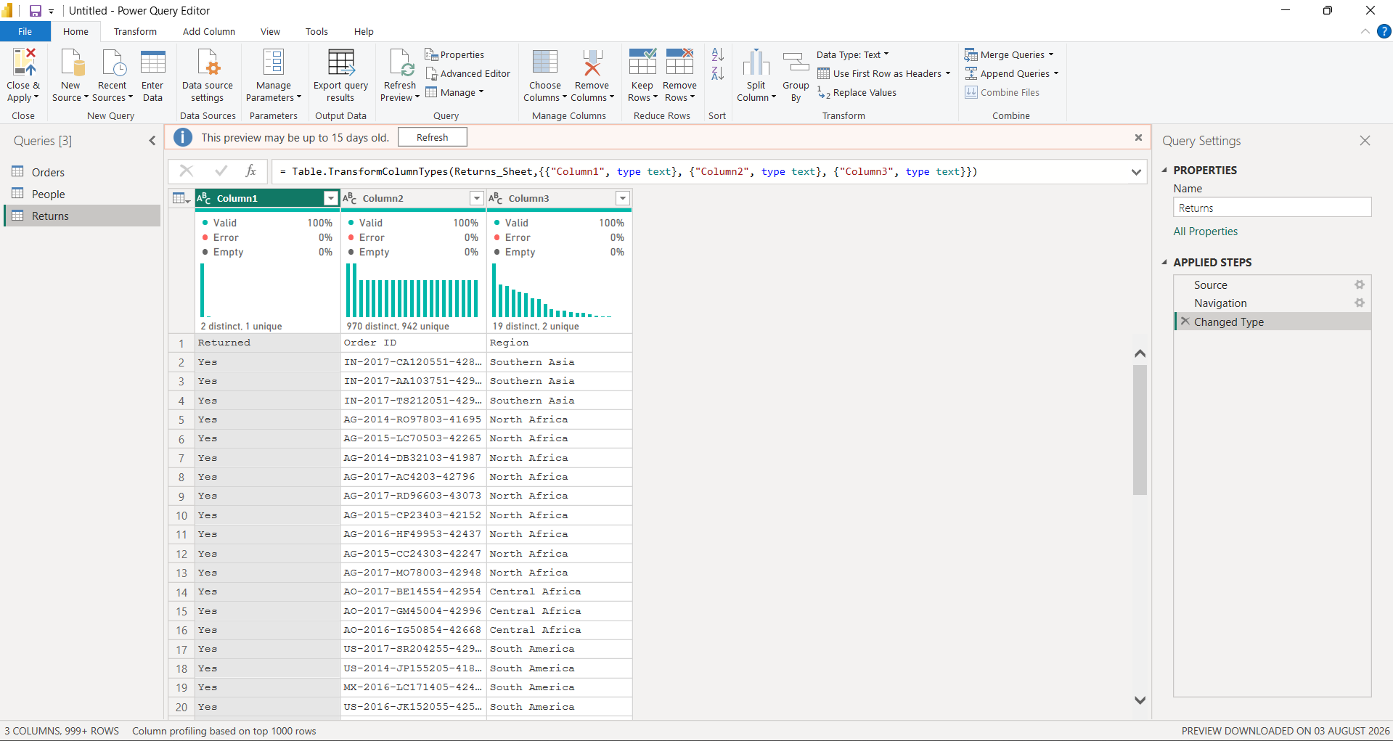

Step 5: Cleanse the 'Orders' table by dropping blank rows, adjusting data types, and creating custom profit margin and date columns.
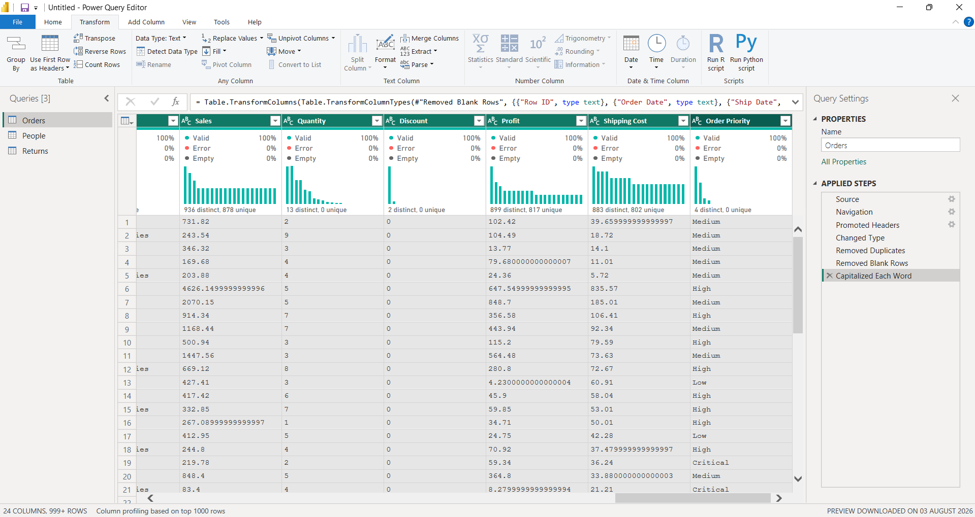

Step 6: Refine the 'Returns' sheet by eliminating duplicate order records, resolving missing metrics, and standardizing return flag parameters.
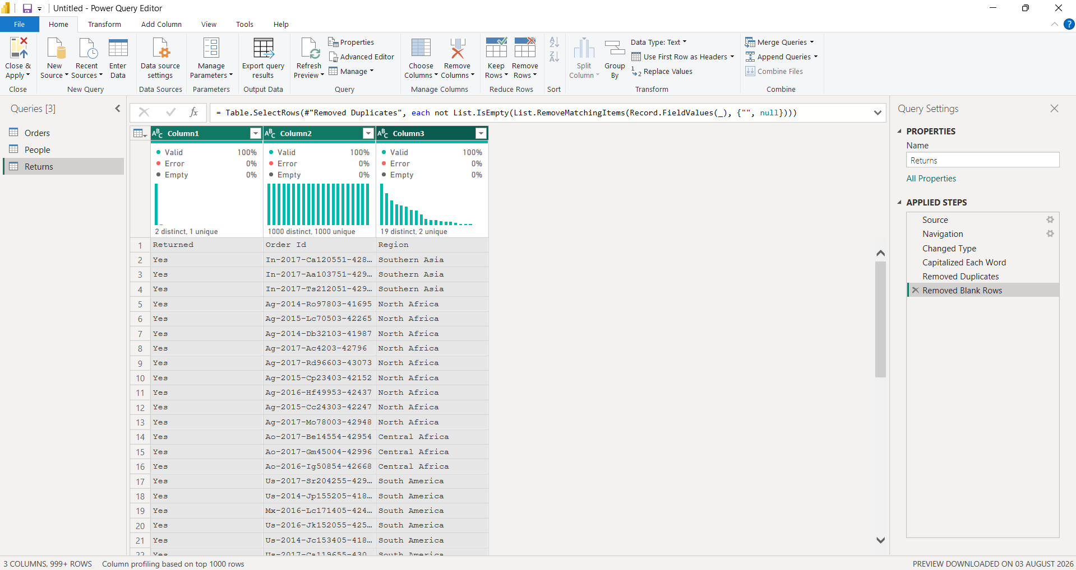

Step 7: Cleanse the 'People' table by verifying regional column text consistency and removing completely unneeded data fields.
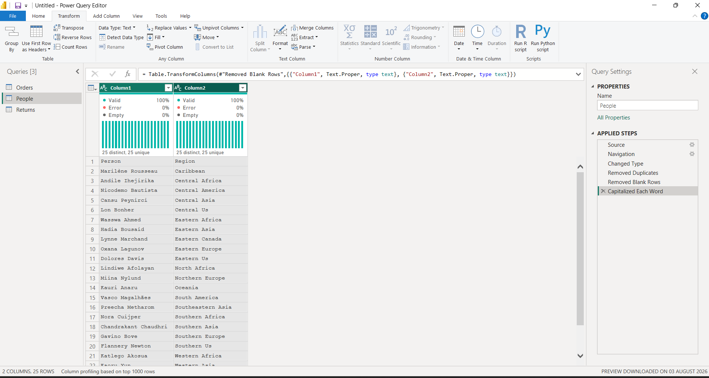

Step 8: Perform a relational merge between the 'Orders' and 'Returns' tables utilizing 'Order ID' as the shared matching primary field.
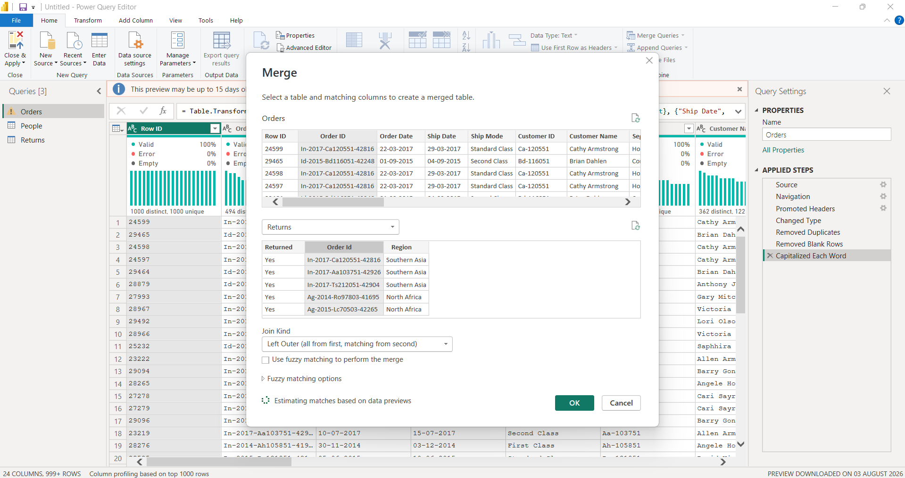

Step 9: Audit your transformation sequences tracked in the 'Applied Steps' list, then choose 'Close & Apply' to commit structural modifications.
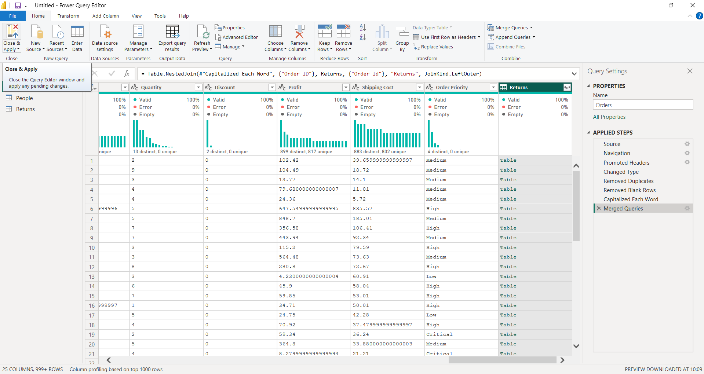

Step 10: Toggle the navigation ribbon to the Model View layout to inspect and organize your imported table schemas.
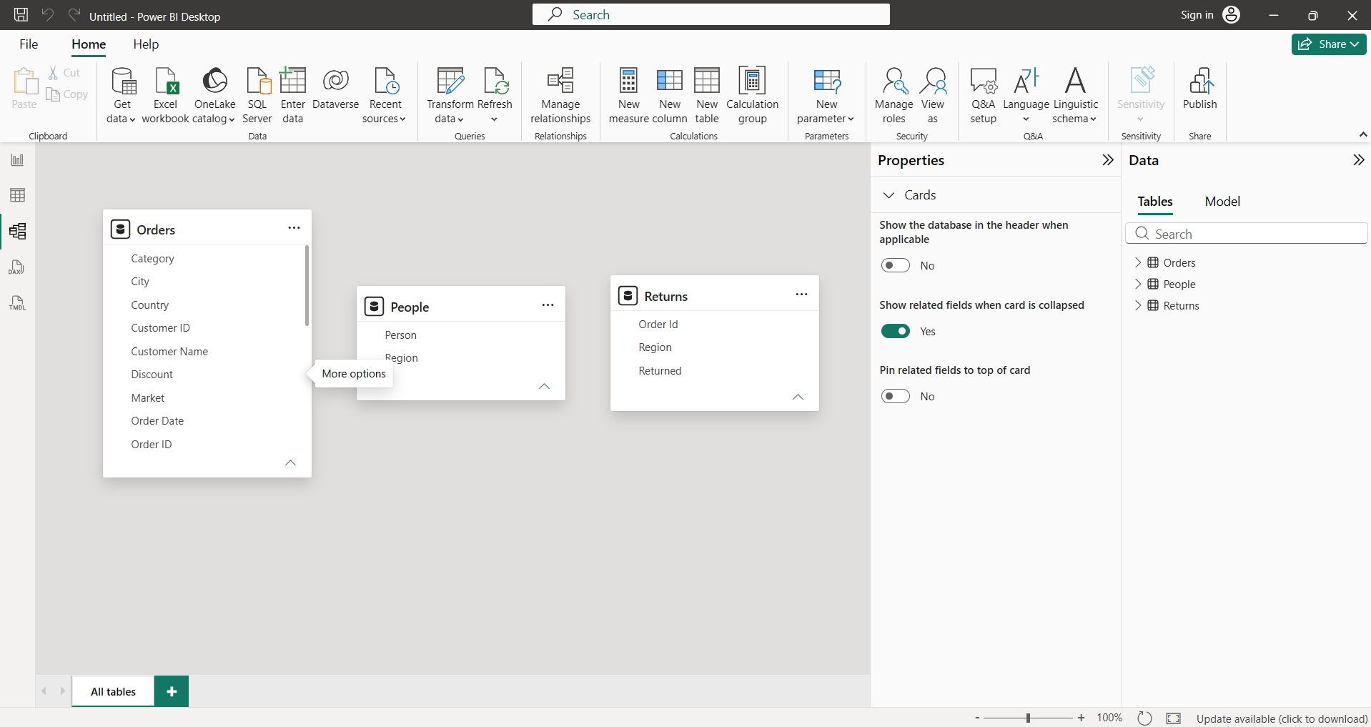

Step 11: Establish required primary table relationships linking 'Orders' to 'Returns' via Order ID and linking 'Orders' to 'People' via Region.
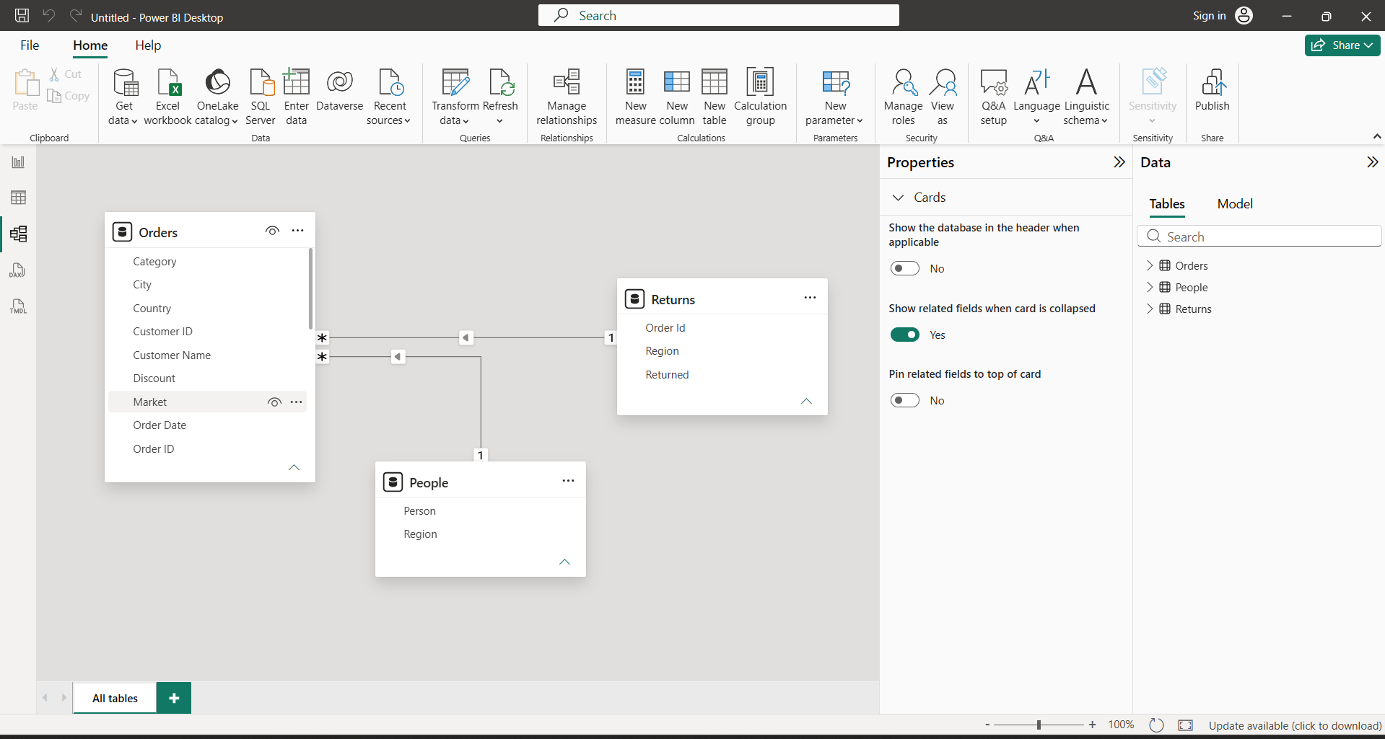

Step 12: Write fundamental analytical DAX formulas to calculate metrics for Total Sales, Total Profit, Profit Margin, and Total Orders.
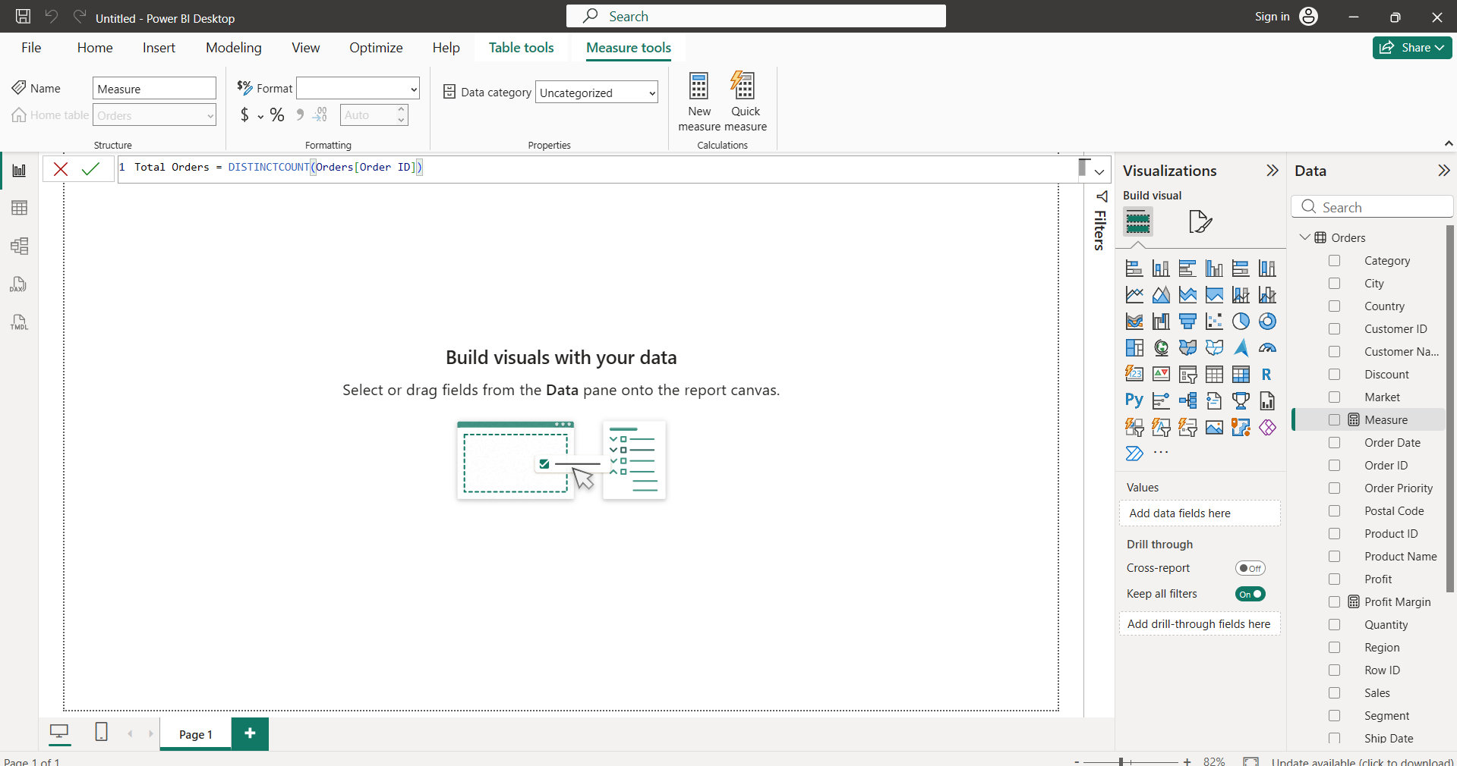Step 13: Build a functional reporting visual matrix using matching contextual attributes collected across your connected dataset schema tables.
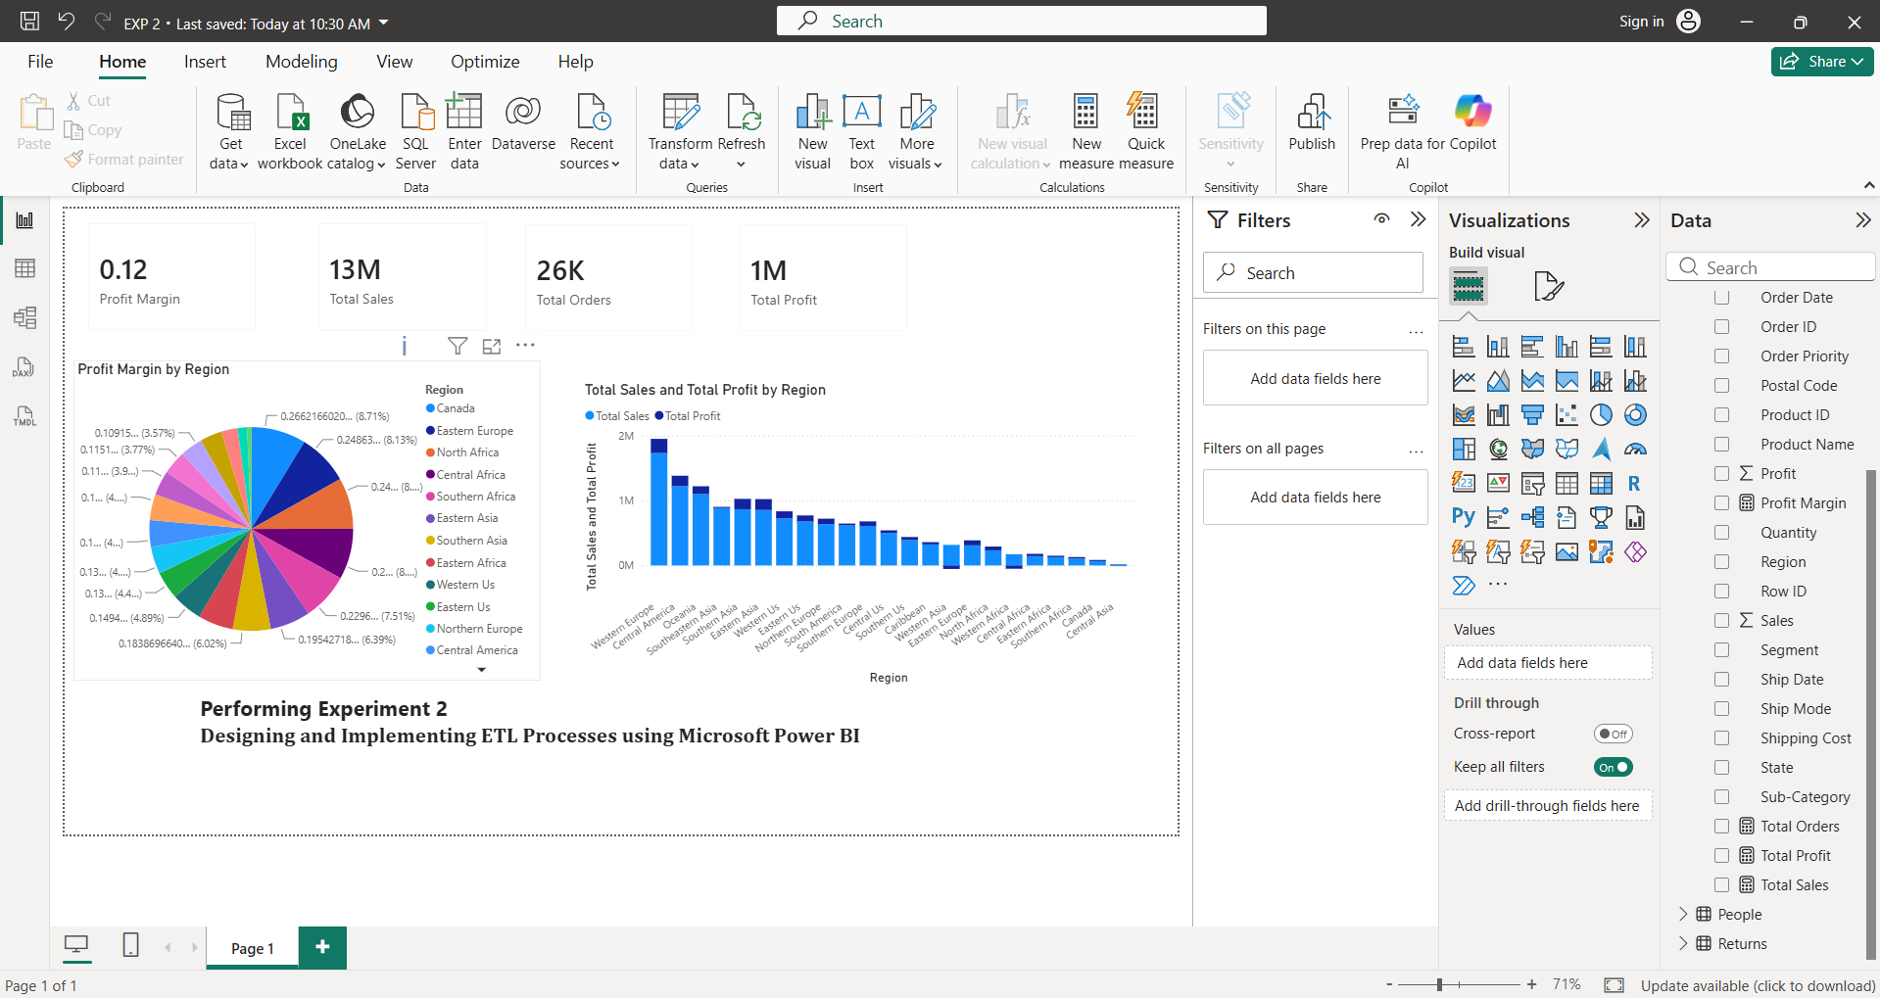

Learning Outcomes:
- Explain the ETL process architecture and describe its fundamental baseline role within enterprise Business Intelligence applications.
- Extract raw administrative metrics out of decentralized, real-world spreadsheet assets using fundamental Power BI connectors.
- Apply intermediate database transformation practices including row filtering, structural text normalization, and multi-table relational schema merging.
- Formulate working data relationship links and execute custom data analysis expressions (DAX) to generate scalable calculation models.
- Validate aggregated and transformed baseline tables to prepare clear relational parameters for visual dashboards and executive reporting environments.

